AMAZON ELASTIC LOAD BALANCERS (ELB)

* **WHAT is ELB?**

Load Balancers have auto-scaling Feature like Dynamically Scale up and Scale Down , have Elasticity Feature based on load and Pressure of an Application in Real-time.

Elastic Load Balancing supports the following types of load balancers:

1. Application Load Balancers,
2. Network Load Balancers, and
3. Classic Load Balancers.

Amazon ECS services can use either type of load balancer. Application Load Balancers are used to route HTTP/HTTPS (or Layer 7) traffic. Network Load Balancers and Classic Load Balancers are used to route TCP (or Layer 4) traffic.

## Application Load Balancer

* So this Load Balancer comes at layer 7 load balanced Platform
* Path And Host Based Routing
* Basically This load balancer manages Web requests and Web applications and protects the web from Malicious requests
* Very High improved performance for real-time and Streaming Applications
* Content Based Routing meaning we can route the requests across Different applications by Single Load Balancer
* Can be applied this Load Balancer For Microservices and Amazon container Service like Amazon ECS

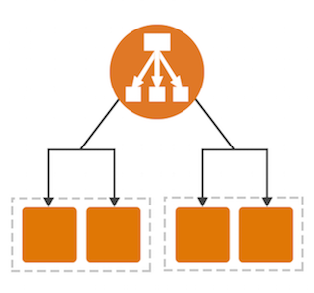

## Network Load Balancer

* So this type of load balancer comes at layer 4 load balanced Platform
* Connection based Loading Balancing meaning it supports TCP ,TLS protocols instead of Http and Https kind of web requests
* So in Security Groups we have to specify Tcp instead of Http , Security Groups nothing but Firewall rules for incoming and outbound Network Rules
* Offers High Performance , Low Latencies and High Throughput, meaning Good for Long running applications



## Classic Load Balancer

* This Load Balancer operates on both Layer 4 and Layer 7 load balanced Platform
* This Load Balancer is a old approach where it supports both Web Requests and Connection Levels
* Now Since this approach is been Deprecated , no longer existing as People use ALB or NLB for modern day applications
* Supports all HTTP/HTTPS,TCP/TLS



## Additional Steps to follow for Load Balancers :

1. Create Virtual private Cloud (VPC) and then create 2 subnets , one Route Table and one IGW , now on-premises and Cloud Connection Done
2. Create 2 EC2 instances in separate Subnets , add Web server (IIS) for each EC2 instance and create Simple HTML pages within EC2 to know the Difference
3. Create one Target Group and add 2 EC2 instances created
4. Next select Load Balancing (select based on application HTTP or TCP/TLS) there name Load Balancer and register Target Group and Security Group mentioned in EC2 instances
5. Finally Generates one DNS address for specific Load Balancer

Attachments and LInks

<https://docs.aws.amazon.com/elasticbeanstalk/latest/dg/environments-cfg-alb.html>